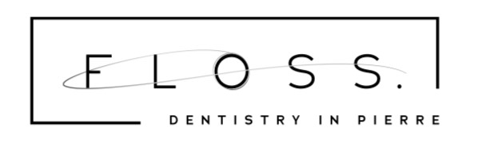

SIGNATURE ON FILE FORM

The undersigned hereby authorizes the release of any information relating to all claims for benefits on behalf on myself and/or dependents. I further expressly agree and acknowledge that my signature on this document authorizes my dentist to submit claims or benefits for services rendered to or to be rendered without obtaining my signature on each and every claim that is submitted for myself and/or my dependents and that I will be bound by this signature as though the undersigned had personally signed the particular claim.

*************************************************************************************************

ACKNOWLEDGEMENT OF RECEIPT OF PRIVACY PRACTICES

I acknowledge that I received a copy of Floss. Dentistry in Pierre’s Notice of Privacy Practices.

**************************************************************************************************
Cancellation Policy

A 24 hour notice is required prior to the appointment time. 2 or more failed appointments and/or same day cancellations can result in dismissal from the practice.

**************************************************************************************************

Financial Responsibility

Patient or parent /guardian is responsible for all charges for services provided by provider that insurance does not cover. If there isn’t insurance coverage, payment is due at time that services are rendered unless an agreement was met prior to services provided. Finance Fees will be charged on your account when a balance is 90 days past due. In the event that the account is sent to collections, you will be responsible for any charges Floss. Dentistry in Pierre incurs from the collection agency.

_________________________________________________________________________________________________
Print Date

Patient or Responsible Party Signature Date

